Image | 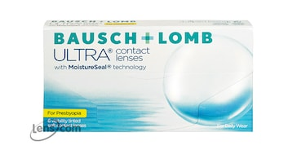
Brand | MICHEAL KORS
Model Name | BAUSH & LOMB ULTRA
Price | RS 1699
PRODUCT DETAILS

